**MINI PROJECT DOCUMENTATION:**

Topic: **ONLINE SHOPPING**

Sub-Topic: **PRODUCT SELECTION**

**ASSUMPTIONS:**

The program started from the product page. It was assumed that the user had logged in with validation prior to this.

The program continues till the point where the user adds products to cart.

**FUNCTIONALITIES:**

The program explored the following major functionalities:

1. Selection of product categories and products
2. Choosing sizes
3. Referring size charts
4. Adding products to cart (while checking the inventory)
5. Viewing cart*

*The operations on the cart have not been explored as that was done by the successesive member of the group.

1. **Selection of products category and products:**

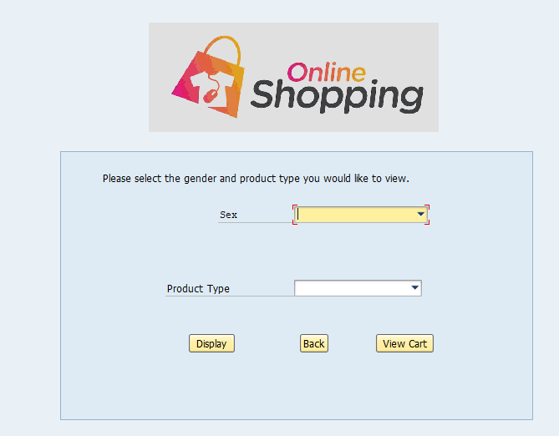

Figure 1

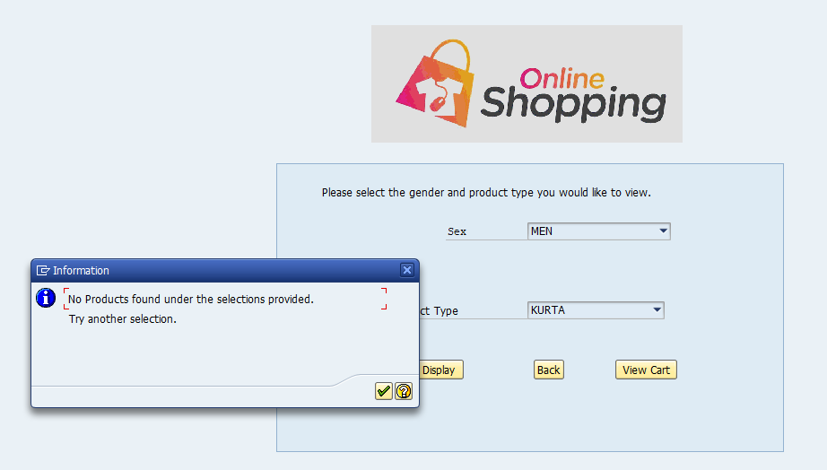

Figure 2

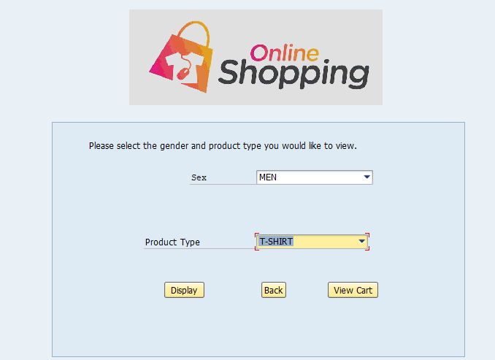

Figure 3

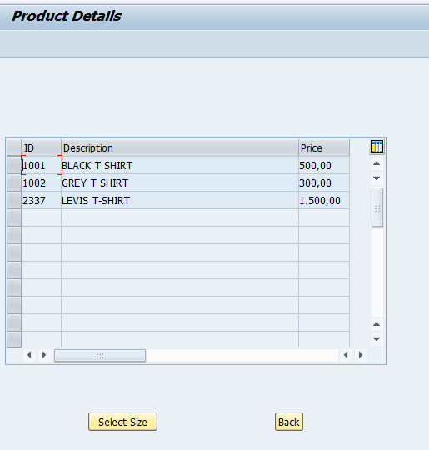

Figure 4

In the first screen (figure1) the user is asked to enter the gender and the type of product he/ she wishes to buy.

If products do not exist in the provided selection, the user gets a message as seen in figure 2.

If the products exist in the provided selection (figure 3), the user is taken to the next screen as seen in figure 4.

From this screen, the user can select the required product and proceed to the screen displaying the sizes available (figure 5) or choose to go back to the previous screen.

1. **Choosing sizes:**

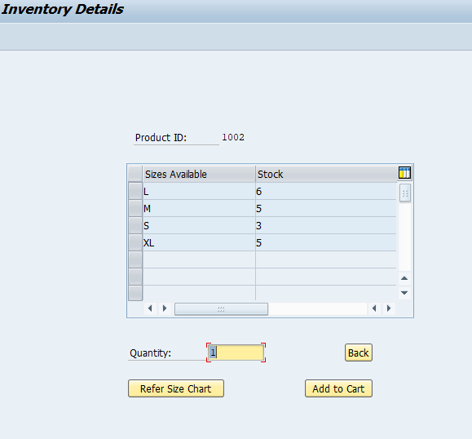

Figure 5

In this screen, the user can see the sizes available for a particular product.

In case of unavailability of sizes, a pop-up screen mentioning ‘out of stock’ appears.

From this screen, the user can return to the previous screen using ‘back’, refer to size chart or add the product of a particular size to the cart.

1. **Referring size charts :**

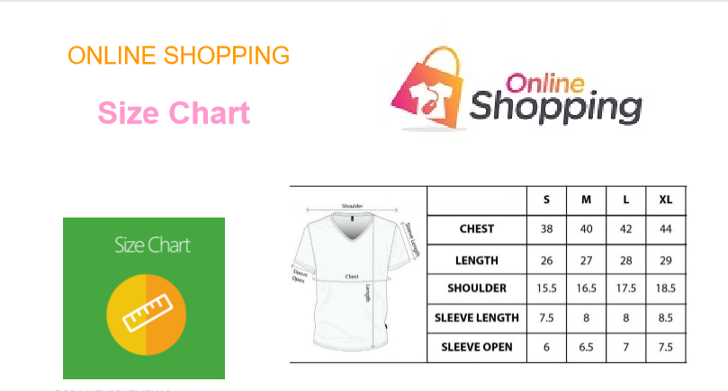

Figure 6

Clicking on ‘Refer Size Chart’ as seen in figure 5, directs the user to the Adobe form with the size charts (figure 6).

Here the user can know the dimensions of the product he/she wants to buy.

1. **Adding products to cart (while checking the inventory):**

The user needs to select a size and mention a quantity before adding the product to the cart from the screen shown in figure 5.

The default quantity is given as 1.

If the user enters a quantity greater the quantity available in the stock, he/she gets an error message as seen in figure 7.

If the quantity entered is available in stock the user gets as success message as seen in figure 8.

From the screen shown in figure 8, the user can choose to go back to select another size of the product added to cart, by clicking ‘back’.

‘Continue Shopping’ takes the user to the screen shown in figure 1, wherehe/she can choose other products he/she wants.

‘View Cart’ option can be used to see the details of all the products present in the cart as seen in figure 9.

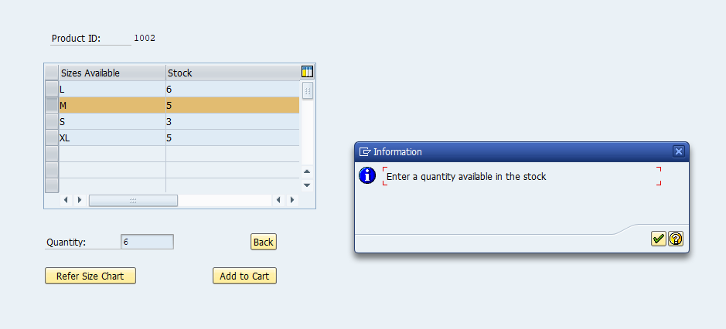

Figure 7

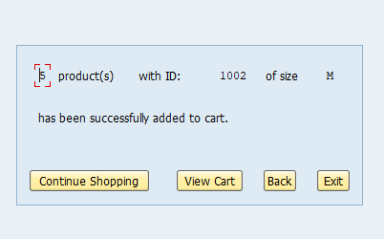

Figure 8

1. **Viewing cart*:**

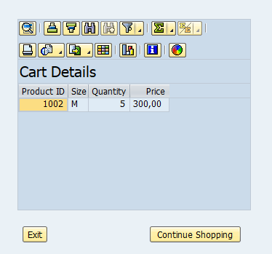

Figure 9

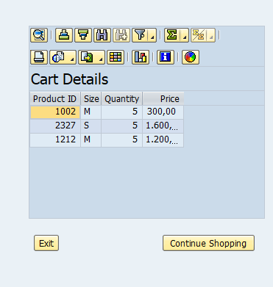

Figure 10

*As mentioned earlier, the operations of the cart has been limited by this member of the project as it was elaborately done by the successive member.

The cart screen can be seen in figure 9 with 2 options: exiting the program or continuing shopping, where the user is taken back to screen displayed in figure 1, so that the user can continue adding more products to the cart.

Upon adding multiple products the cart screen would look like figure 10.